# **Assignment 1**

# **Robotics**

1. Explain SCARA robot configuration with a neat figure.
2. Explain the classification of Robots as per Robotics Institute of America.
3. Explain any two types of robot reference frames.
4. Differentiate between Servo and Non-servo control systems.
5. Derive 3D rotation matrix along X, Y, and Z-axis using direction cosine representation.
6. The coordinates point P in a reference frame are [8, 6, 4]T. If the reference frame is rotated at an angle 45° along Z-axis, find the coordinate of point P in rotated frame.
7. The coordinates point P in a reference frame are [15, 3, 8]T. If the reference frame is rotated at an angle 60° along Y-axis, find the coordinate of point P in rotated frame.
8. Write a MATLAB program to animate one-link robot.
9. Write a MATLAB program to animate two-link robot.
10. Define Singularity and Write the properties of rotation matrix.
11. Explain various types of joints used in robots.
12. Find the DH-parameters for the following 3-link robot.

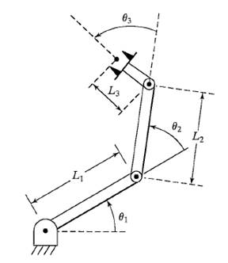

1. Find the DH-parameters for the following RP robot.

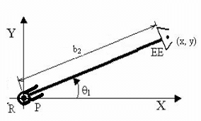

1. Derive the position and velocity of the two-link robot. Also, derive its Jacobian Matrix.
2. Define Jacobian and derive the position and velocity of the one-link robot.
3. Calculate the Jacobian of a two-link planar arm when θ1= 45º and θ2= 20º
4. Derive the inverse kinematic solution of a two-link manipulator.
5. Derive the inverse kinematic solution of a three-link manipulator.
6. Write a note on progressive advancements in robots.
7. Write a note on Robot programming language.
8. Explain different application fields of robots.
9. Define the following:
   1. Workspace
   2. Degrees of Freedom
   3. Rover
   4. Actuators
   5. Robot controller
   6. Point-to-point robot
   7. Continuous path-controlled robot
10. Write the classification of sensors.
11. Define kinetic energy and derive the kinetic energy of two-link robotic arm.
12. Derive the dynamic equation of motion of one-link robotic arm.